**What is the Salesforce CPQ Product object?**

* Product object is a key component of the Salesforce CPQ application. It is designed to represent individual products or services within the CPQ framework.
* It is the Standard Product object only (Product2) but Salesforce CPQ extends the functionality and optimizes it by adding some package fields.
* It is the main object that stores and organizes the information about your products in a structured manner.
* Only Products with an active price book will be visible on the QLE page.
* Here are some key aspects of the Salesforce CPQ Product object-
  + **Product Details**: Stores information like product name, description, code, SKU (Stock Keeping Unit), and any other relevant details that describe the product.
  + **Pricing**: You can define the price of a product by setting the base price, applying price lists or schedules, defining discounts, and configuring pricing rules based on specific criteria
  + **Product Family and Categories:**Product families allow you to group related products together, while categories provide a hierarchical structure for organizing products based on different criteria.
  + **Product Relationships**: The Product object enables you to establish relationships between different products
  + **Configurable Attributes:**Within the Product object, you can define configurable attributes. It allows for product customization. These attributes can be used to capture different options, variations, or features of a product. For example, you can define attributes for color, size, memory capacity, or any other product-specific characteristics.
  + **Integration with Configurations:**The Product object integrates seamlessly with the configuration capabilities of Salesforce CPQ. It allows you to define dependencies, constraints, and rules for product configurations, ensuring that only valid combinations and options are available during the quoting process.

**Type of Product Object:**

Product types in Salesforce CPQ allow businesses to create dynamic and customizable offerings, configure pricing rules, handle complex product configurations, and streamline the quoting and sales process.

We have 6 types of Products -

1. Non-Subscription or One-Time Product
2. Subscription Product
3. Multi-Dimensional Quoting (MDQ) Product
4. Usage Based Product
5. Bundle Product
6. Perpetual Product

**[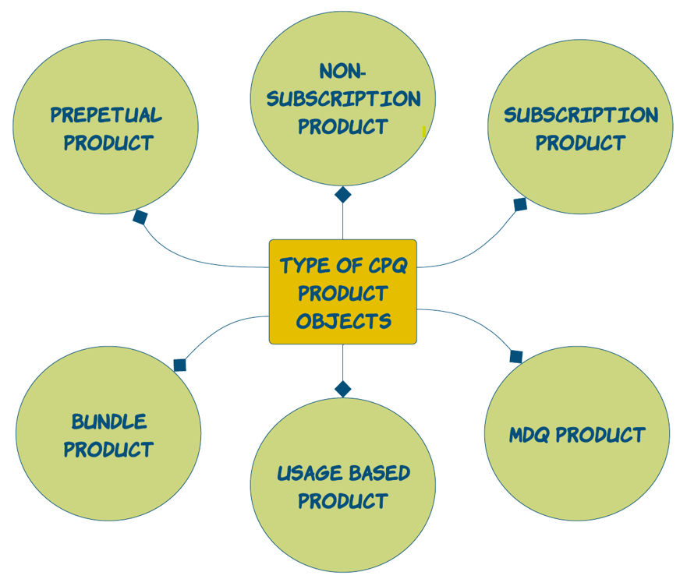](https://www.blogger.com/blog/post/edit/5479395999909322176/3214906548246170862)**

**1. Non-Subscription/One-Time Product:**

* As the name suggests such products are sold as one-time purchases or do not involve recurring billing or subscription-based pricing.
* These products are typically purchased once and do not require ongoing payments or renewals
* Upon converting these products **convert to asset** options chosen in Asset Conversion Field ( One per unit, one per quote line, or None).
* Example: Purchase Burger, Laptop or Mobile

**Steps to Create Non-Subscription Products**-

1. Navigate to App Launcher
2. Select Salesforce CPQ
3. Click on Products and Click on New
4. Provide a product name, a unique product code, and a product family, and activate the product
5. Admins can create additional custom fields on products as required.
6. Products need to be activated and added to a standard price book.

[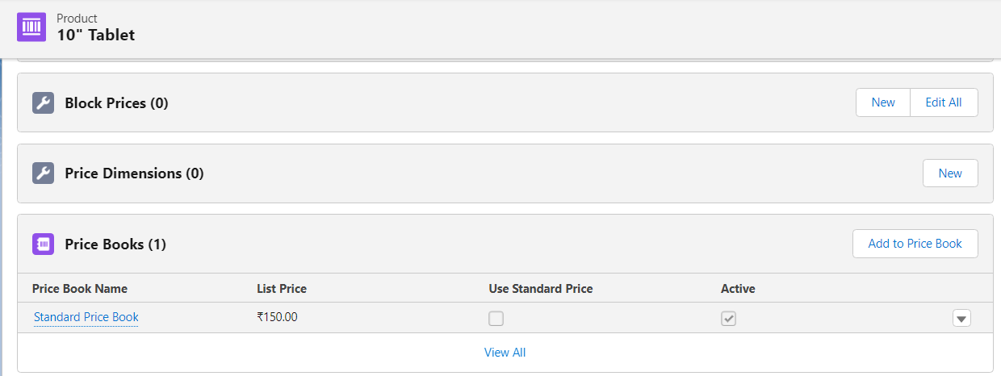](https://www.blogger.com/blog/post/edit/5479395999909322176/3214906548246170862)

**2. Subscription Product:**

* Subscription products are sold as services that last for a specific period (whether that's days, months, or years). Subscription products have recurring payments associated with them.
* Upon contracting these products become a Subscription **associated with the Contract and renewals can be generated.**
* **Example:**Netflix or Amazon Prime. Or buying a cell phone subscription for a month.

**Required Fields and Attributes for Subscription Product-**

1. **Subscription Type:**This field tells us how Salesforce CPQ handles renewals. This picklist field has 4 values out of the box -   
   **A**. **Renewable**includes subscriptions in a renewal quote  
   **B**. **One-time** subscriptions will not include products in renewal quotes. Note that there is a Preserve Bundle Structure package setting in CPQ that, when activated, adds one-time subscriptions to a renewal  
   **C**. **Evergreen** subscriptions remain active until canceled and cannot be renewed. Note that these evergreen subscriptions cannot be on the same contract as renewable or one-time subscriptions. CPQ will always split them out automatically.  
   **D**. **Evergreen/renewable** subscriptions are renewable, or evergreen, on individual quote lines in the quote line editor (QLE). These values can be manually selected or automated using Apex or a flow

[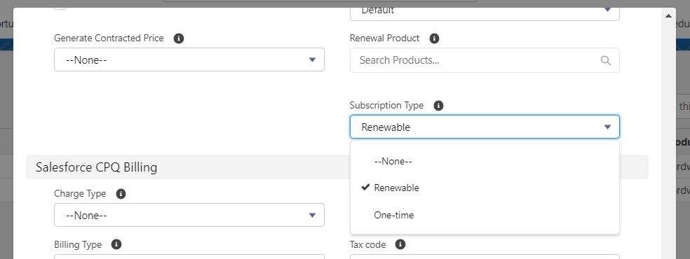](https://www.blogger.com/blog/post/edit/5479395999909322176/3214906548246170862)

Please Note by default you will only get 2 options as shown in the above image - Renewable and One-time. To enable Evergreen/renewable picklist options you need to edit the **Enable Evergreen Subscriptions**checkbox in the **Subscription and Renewals tab**on the installed package configuration page. Once enabled, it can not be disabled. [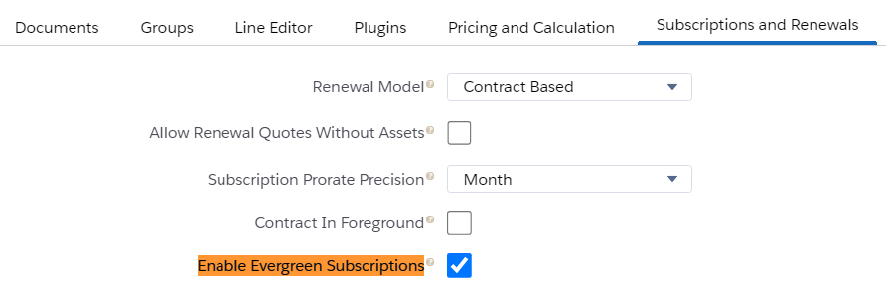](https://www.blogger.com/blog/post/edit/5479395999909322176/3214906548246170862)

1. **Subscription Pricing:** After adding the subscription fields in the product object next step os to set the pricing. It has 2 picklist options -   
   **A. Fixed Price:**Products get their list price from the price book  
   **B. Percentage of total:** The product's list price is a percentage of either the quote, the quote line group, or a bundle's total price.

[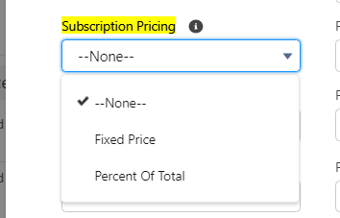](https://www.blogger.com/blog/post/edit/5479395999909322176/3214906548246170862)

**Subscription Term:**This field tells the number of months/years of subscription. For example, Sales reps need to configure the Netflix Subscription which will renew in every 1 month. In that case, the Subscription Term should be 1. Now the unit of measure (months/years) will be controlled from salesforce CPQ package settings

[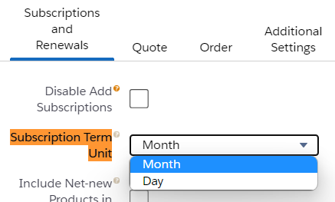](https://www.blogger.com/blog/post/edit/5479395999909322176/3214906548246170862)

Interview Questions:

* 1. How to setup a subscription based product that never end its subscription?
  2. How CPQ identify if a product is a subscription based or non-subscription based?
  3. What is price book?
  4. Can we tag a product to a custom price book and ignore standard price book?